In today's fast-paced digital world, capturing attention is a constant battle. Marketers, ever the resourceful bunch, have discovered a powerful weapon in their arsenal: pop culture. By cleverly integrating trending topics, memes, and cultural phenomena into marketing campaigns, brands can tap into a shared social experience and forge deeper connections with their target audience. Imagine a shoe company launching a line of sneakers inspired by the latest superhero movie, instantly appealing to fans who want to incorporate that cultural touchstone into their wardrobe. Pop culture becomes a bridge between brand and consumer, fostering a sense of shared interest and excitement.

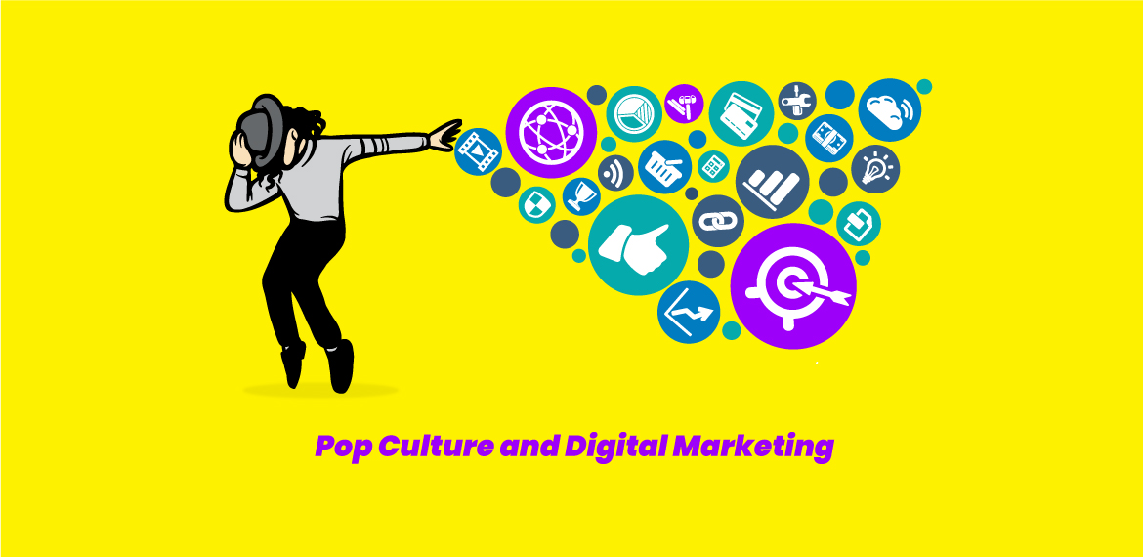

The beauty of pop culture marketing lies in its versatility. A well-timed and witty tweet referencing a popular show can spark viral engagement, while a carefully crafted influencer campaign featuring a celebrity aligned with the brand's values can generate significant buzz. Imagine a beauty brand partnering with a makeup artist known for their fantastical creations to develop a limited-edition product line, drawing in beauty enthusiasts captivated by the influencer's artistry. Pop culture allows brands to speak the language of their audience, creating a sense of authenticity and relevance that resonates on a deeper level.

However, wielding the pop culture weapon requires a delicate touch. Marketers must tread carefully, ensuring their integration feels genuine and not forced. A shoehorned reference or a meme that misses the mark can backfire spectacularly. The key lies in understanding the target audience, staying up-to-date on current trends, and injecting a dose of creativity into the campaign. By embracing pop culture thoughtfully, marketers can create campaigns that are not just informative, but also entertaining and culturally relevant, leaving a lasting impression on their audience.